Report

By

### B20MT005 and M21AIE208

a. The assignment is done using R as well as python

b. Dataset used is 100 Yen/INR exchange rate and gathered from RBI website

c. We will analyze daily timeframe data from the period 27-08-1998 to 30-12-2022

Libraries used : library(lubridate), library(tseries) ,library(Metrics)

**Part 1**

**ARMA/ ARIMA and its variation**

**Step 1: Loading the data**

No of datapoints 5943

No of columns in the data 2

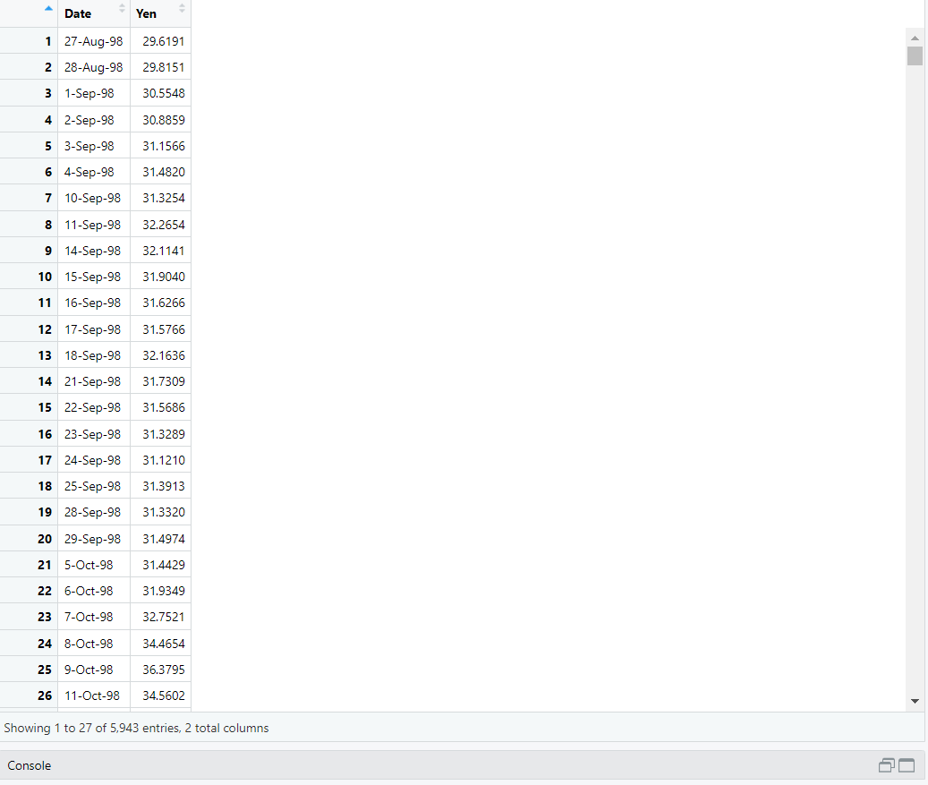

**Step 2: Plotting time series**

Note that :

Data is for 100JPY to inr

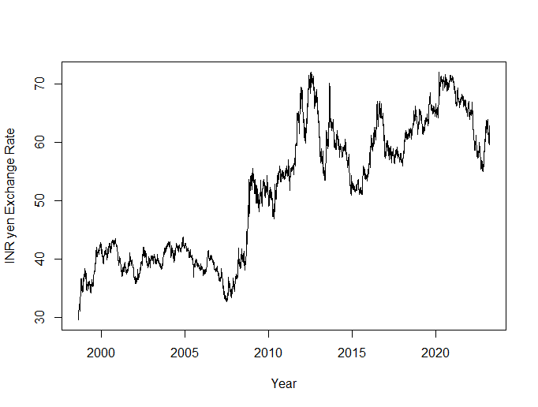

**Step 3: Test for non-stationarity using ADF and PP**

ADF Test

The augmented Dickey-Fuller (ADF) test is a formal statistical test for stationary check.

The null hypothesis assumes that the series is non-stationary.

The null-hypothesis for an ADF test is that the data are non-stationary.

So p-value greater than 0.05 indicates non-stationary, and p-values less than 0.05 suggest stationary.

Augmented Dickey-Fuller Test

data: ts(train_set)

Dickey-Fuller = -0.76101, Lag order = 6, p-value = 0.9641

alternative hypothesis: stationary

This test is also used to check whether time series is stationary or not.

In the KPSS test, the null-hypothesis is that the data are stationary.

In this case, p-value less than 0.05 indicates non-stationary series and p-value greater than 0.05 indicates stationary series.

KPSS Test for Level Stationarity

data: ts(train_set)

KPSS Level = 2.7596, Truncation lag parameter = 4, p-value = 0.01

ADF and PP statistics and p-value rejects the null hypothesis for stationarity, hence this series is non- stationary

Since the p-value of the KPSS test (0.01) is less than 0.05, and p-value of ADF test (0.9641) greater than 0.05 it indicates the time series is non-stationary.

Ljung-Box test

The Ljung-Box test is a classical hypothesis test that is designed to test whether a set of auto-correlations of a fitted time series model differ significantly from zero.

Box-Ljung test

data: train_set

X-squared = 236.63, df = 1, p-value < 2.2e-16

Step 5: Test for non-stationarity at First Difference of the series using Autocorrelation and Partial Autocorrelation

**ACF**

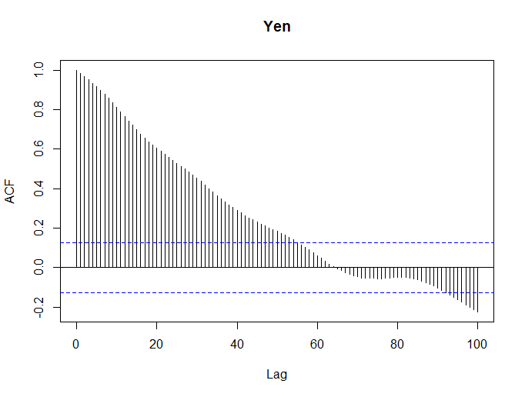

Since the ACF plot shows that Auto-correlation is dropping immediately after the first lag and we can use the ARIMA model.

**PACF**

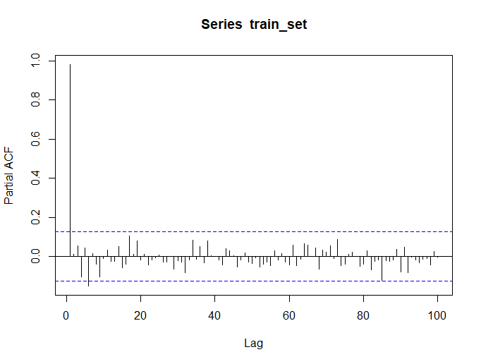

Step 5: Building ARIMA model

ARIMA models and its variation based on ARIMA(p,d,q)

1. ARIMA model [Order (5,0,1)]

ar1 ar2 ar3 ar4 ar5 ma1 intercept

0.36083566 0.54425914 0.14350579 -0.11337687 0.04388598 0.66131358 125.67301205

ar1 ar2 ar3 ar4 ar5 ma1

ar1 0.0418229563 -0.039239303 0.0008243126 -0.012485313 0.009693083 -0.038125233

ar2 -0.0392393026 0.042374953 -0.0036943080 0.010002613 -0.009980822 0.038156295

ar3 0.0008243126 -0.003694308 0.0059788948 -0.001547030 -0.001506166 -0.003133697

ar4 -0.0124853135 0.010002613 -0.0015470302 0.008246349 -0.004349280 0.011906828

ar5 0.0096930828 -0.009980822 -0.0015061655 -0.004349280 0.006358445 -0.009373762

ma1 -0.0381252331 0.038156295 -0.0031336966 0.011906828 -0.009373762 0.038535615

intercept 0.1055985829 -0.140745994 0.0134920154 0.028952955 0.137072107 -0.124768683

intercept

ar1 0.10559858

ar2 -0.14074599

ar3 0.01349202

ar4 0.02895295

ar5 0.13707211

ma1 -0.12476868

intercept 1488.18075642

> model1[["aic"]]

[1] 1789.788

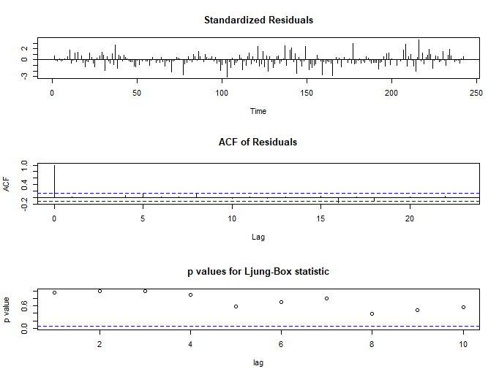

b. ARIMA [Order(10,0,1)]

ar1 ar2 ar3 ar4 ar5 ar6 ar7 ar8

0.12037479 -0.10593337 0.12402962 -0.08091159 0.18949156 -0.06277169 0.05253006 0.09779418

ar9 ar10 ma1

-0.02053705 -0.02621571 -0.09164079

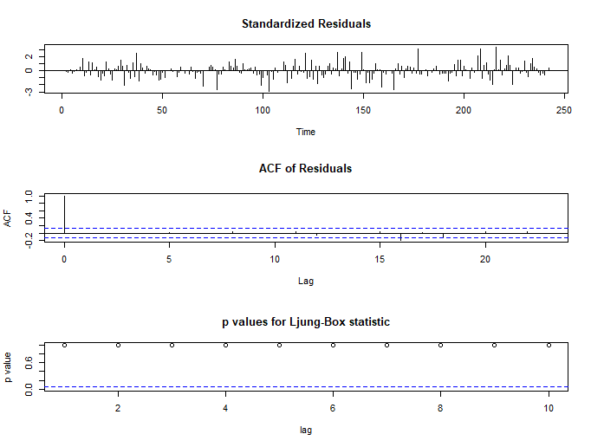

> model2[["aic"]]

[1] 1780.629

Step:9 Testing ARIMA models

|  |  |  |
| --- | --- | --- |
| **Model** | **Order** | **MSPE** |
| ARIMA model 1 | [5,0,1] | 0.8161 |
| ARIMA model 2 | [10,0,1] | 0.8499 |

**Debold Mariano Test**

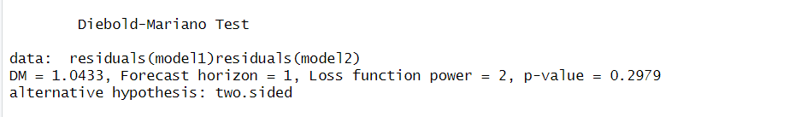

Since we can reject the null hypothesis of Debold Mariano test at 3% which suggest both forecaster are similar and MSPE show **model 1 is performing better**.

**Step 10**: Exchange Forecast for next 10 days using ARIMA model 1

We are predicting the first period ahead forecast for 10 points i.e 2nd Jan 2023 till 11th Jan 2023

Predicted Results from ARIMA model1

|  |  |
| --- | --- |
| Date | Predicted value |
| 2-1-2023 | 61.82643 |
| 3-1-2023 | 61.95222 |
| 4-1-2023 | 61.85266 |
| 5-1-2023 | 61.88815 |
| 6-1-2023 | 61.87390 |
| 9-1-2023 | 61.86109 |
| 10-1-2023 | 61.86307 |
| 11-1-2023 | 61.85056 |

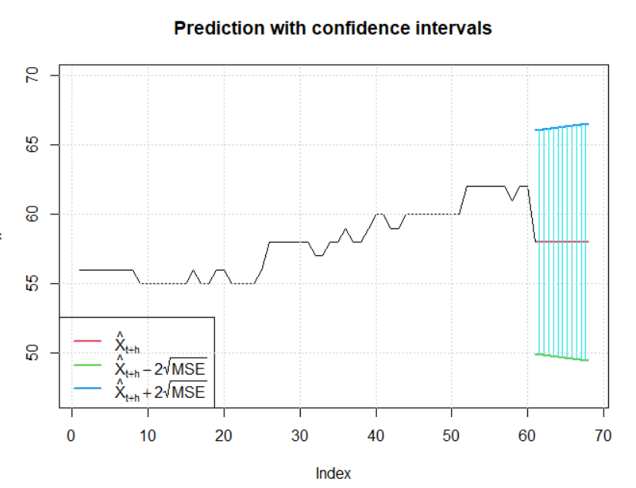

Figure ARIMA model1 forecast value

**Part 2**

ARCH/ GARCH and its variation

Stationarity of the data is already checked in Step1 till Step4

Step 5: Building 2 different ARCH model

1. ARCH model with lag 5

2. ARCH model with lag 10

> ArchTest(ts(train_set))

ARCH LM-test; Null hypothesis: no ARCH effects

data: ts(train_set)

Chi-squared = 15980, df = 12, p-value < 2.2e-16

Because the p-value is < 0.05, we reject the null hypothesis and conclude the presence of ARCH(1) effects.

**Step:6** Fitting ARCH model on train data

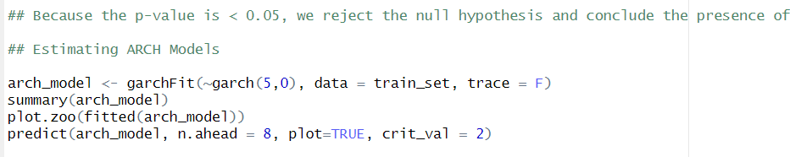

**Arch model summary**

Title:

GARCH Modelling

Call:

garchFit(formula = ~garch(5, 0), data = train_set, trace = F)

Mean and Variance Equation:

data ~ garch(5, 0)

<environment: 0x000001cc0b3f15e8>

[data = train_set]

Conditional Distribution:

norm

Coefficient(s):

mu omega alpha1 alpha2 alpha3 alpha4 alpha5

5.7998e+01 2.7402e-01 1.0000e+00 1.0000e-08 1.0000e-08 1.0000e-08 1.0000e-08

Std. Errors:

based on Hessian

Error Analysis:

Estimate Std. Error t value Pr(>|t|)

mu 5.800e+01 9.488e-02 611.303 < 2e-16 ***

omega 2.740e-01 7.580e-02 3.615 3e-04 ***

alpha1 1.000e+00 1.262e-01 7.927 2.22e-15 ***

alpha2 1.000e-08 1.672e-01 0.000 1e+00

alpha3 1.000e-08 1.453e-01 0.000 1e+00

alpha4 1.000e-08 4.149e-02 0.000 1e+00

alpha5 1.000e-08 NaN NaN NaN

---

Signif. codes: 0 ‘***’ 0.001 ‘**’ 0.01 ‘*’ 0.05 ‘.’ 0.1 ‘ ’ 1

Log Likelihood:

-508.3546 normalized: -2.100639

Description:

Wed Apr 5 21:48:26 2023 by user: Ajay Kumar GGN

Standardised Residuals Tests:

Statistic p-Value

Jarque-Bera Test R Chi^2 15.73919 0.0003821887

Shapiro-Wilk Test R W 0.9026344 2.013482e-11

Ljung-Box Test R Q(10) 1119.819 0

Ljung-Box Test R Q(15) 1388.308 0

Ljung-Box Test R Q(20) 1540.929 0

Ljung-Box Test R^2 Q(10) 14.40654 0.1552424

Ljung-Box Test R^2 Q(15) 17.00462 0.3185885

Ljung-Box Test R^2 Q(20) 31.95976 0.04372898

LM Arch Test R TR^2 15.59144 0.2106731

Information Criterion Statistics:

AIC BIC SIC HQIC

4.259129 4.360049 4.257518 4.299783

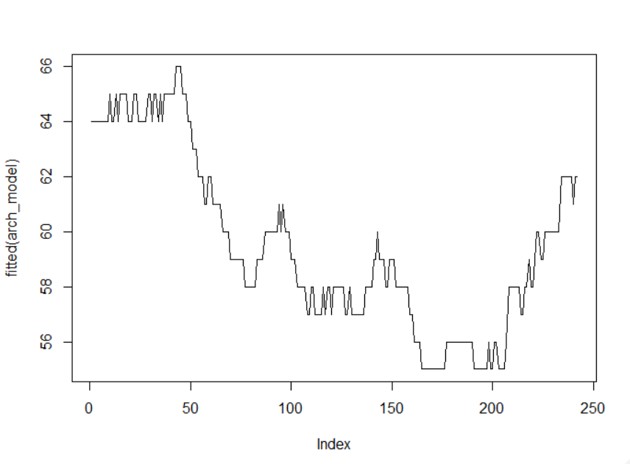

Figure ARCH model fit on the data

**Step 7**: Exchange Forecast for next 10 days using ARCH model 1

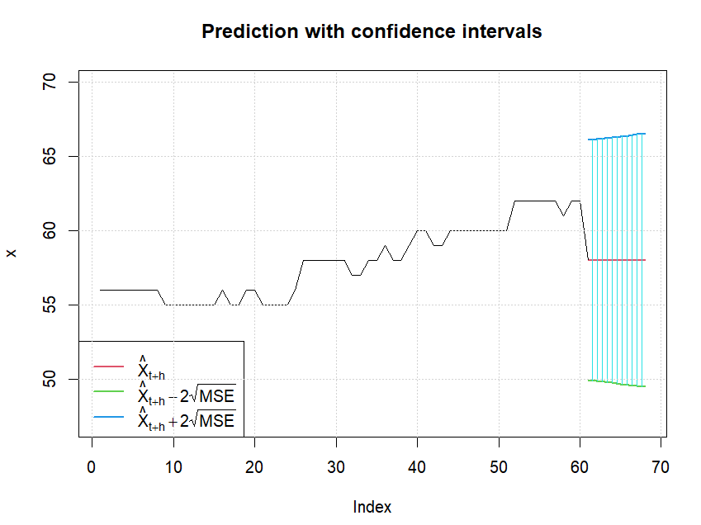

**Garch model and its Variations**

*---------------------------------*

* GARCH Model Fit *

*---------------------------------*

Conditional Variance Dynamics

-----------------------------------

GARCH Model : sGARCH(1,1)

Mean Model : ARFIMA(0,0,0)

Distribution : std

Optimal Parameters

------------------------------------

Estimate Std. Error t value Pr(>|t|)

mu 2.0028e+03 2.050901 976.556594 0.00000

omega 4.5630e+04 885.539701 51.527875 0.00000

alpha1 9.9855e-01 0.028376 35.190479 0.00000

beta1 2.0400e-04 0.031605 0.006467 0.99484

shape 9.8404e+01 18.923130 5.200207 0.00000

Robust Standard Errors:

Estimate Std. Error t value Pr(>|t|)

mu 2.0028e+03 1.32317 1.5136e+03 0.00000

omega 4.5630e+04 2742.24045 1.6640e+01 0.00000

alpha1 9.9855e-01 0.16740 5.9650e+00 0.00000

beta1 2.0400e-04 0.16913 1.2080e-03 0.99904

shape 9.8404e+01 16.31738 6.0306e+00 0.00000

LogLikelihood : -139517.8

mu omega alpha1 beta1 shape

2.002820e+03 4.562998e+04 9.985517e-01 2.043745e-04 9.840419e+01

*---------------------------------*

* GARCH Model Fit *

*---------------------------------*

Conditional Variance Dynamics

-----------------------------------

GARCH Model : fGARCH(1,1)

fGARCH Sub-Model : TGARCH

Mean Model : ARFIMA(0,0,0)

Distribution : std

Optimal Parameters

------------------------------------

Estimate Std. Error t value Pr(>|t|)

mu 6.3421e+03 79.308704 79.967118 0

omega 4.4392e+04 929.878930 47.739958 0

alpha1 5.4130e-03 0.000212 25.565459 0

beta1 0.0000e+00 0.012949 0.000005 1

eta11 -9.9964e-01 0.050013 -19.987583 0

shape 2.1000e+00 0.001571 1337.130518 0

Robust Standard Errors:

Estimate Std. Error t value Pr(>|t|)

mu 6.3421e+03 3.1958e+02 19.845133 0

omega 4.4392e+04 3.9085e+03 11.357895 0

alpha1 5.4130e-03 3.9800e-04 13.586043 0

beta1 0.0000e+00 8.8591e-02 0.000001 1

eta11 -9.9964e-01 1.1792e-01 -8.477529 0

shape 2.1000e+00 4.7140e-03 445.498482 0

LogLikelihood : -168417.6

*---------------------------------*

* GARCH Model Fit *

*---------------------------------*

Conditional Variance Dynamics

-----------------------------------

GARCH Model : fGARCH(1,1)

fGARCH Sub-Model : APARCH

Mean Model : ARFIMA(0,0,0)

Distribution : std

Optimal Parameters

------------------------------------

Estimate Std. Error t value Pr(>|t|)

mu 2.8180e+04 NA NA NA

archm -2.8285e-02 NA NA NA

omega 9.5922e+02 NA NA NA

alpha1 5.0000e-02 NA NA NA

beta1 9.0000e-01 NA NA NA

eta11 5.0000e-02 NA NA NA

lambda 1.0000e+00 NA NA NA

shape 4.0000e+00 NA NA NA

Robust Standard Errors:

Estimate Std. Error t value Pr(>|t|)

mu 2.8180e+04 NA NA NA

archm -2.8285e-02 NA NA NA

omega 9.5922e+02 NA NA NA

alpha1 5.0000e-02 NA NA NA

beta1 9.0000e-01 NA NA NA

eta11 5.0000e-02 NA NA NA

lambda 1.0000e+00 NA NA NA

shape 4.0000e+00 NA NA NA

failed to invert hessian

LogLikelihood : -1.1